Color Game

You will create a game where the user will read the RGB color code displayed at the top, then click on color block that matches the RGB color code. The game will end when the user clicks on the correct block. The colors will be need to be completely random (*Hint: You will need to use the Math object to randomize the colors for each block)*.   
The game has two difficulties; Easy displays 3 blocks & Hard displays 6 blocks.   
The menu has 3 buttons - New Colors, Easy, & Hard. New Colors button will display a set of different colors.   
A message will display in the center of the menu to notify the use if they’ve selected the right or wrong block.

Create your own HTML & CSS as what is displayed below. Create a separate .js file to put your code in.

Use: Functions, Event Listeners, loops, if/else statements, this, style methods.

(Look at the images below and read the captions below each of them)

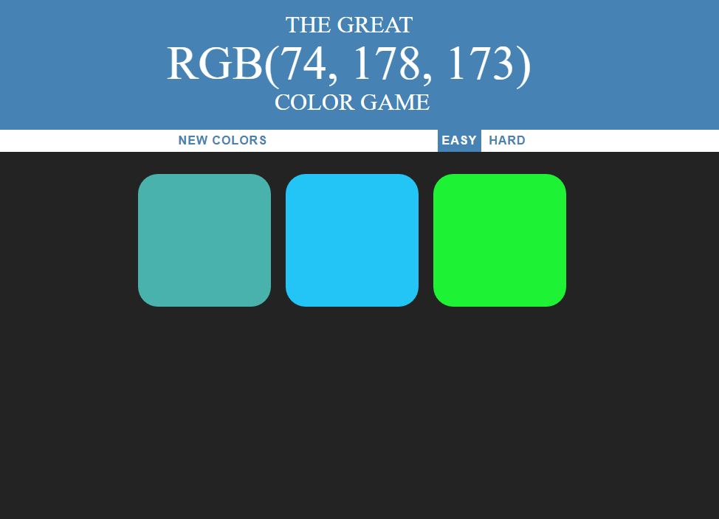

Figure 1: Game is on easy mode. In order for the user to guess right they would have clicked the teal colored first block.

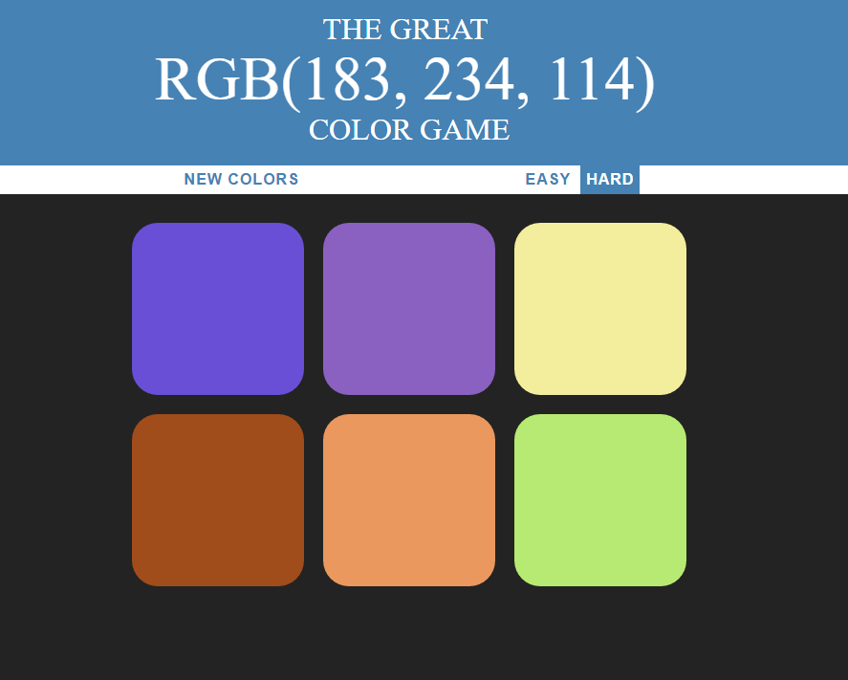

Figure 2: Game is now on hard displaying 6 blocks. The correct block would be the lime color on the bottom-right.

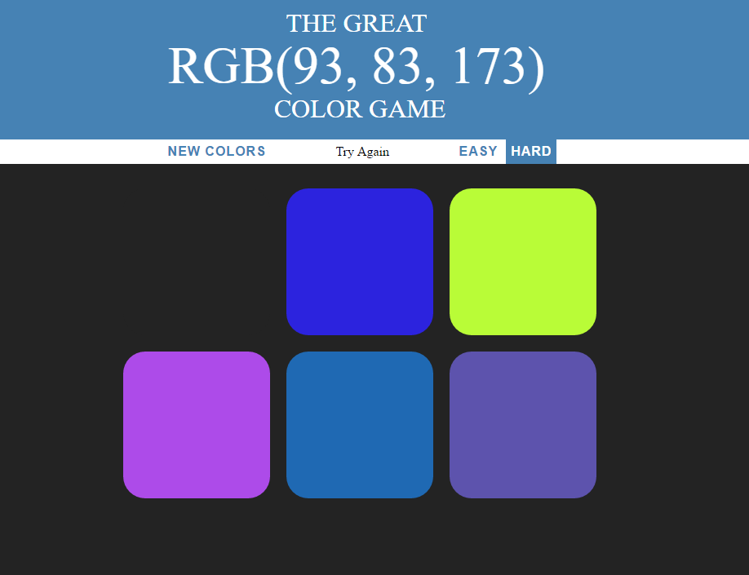

Figure 3: Anytime the user clicks the wrong block it will disappear with a message displaying "Try Again" near the top-center.

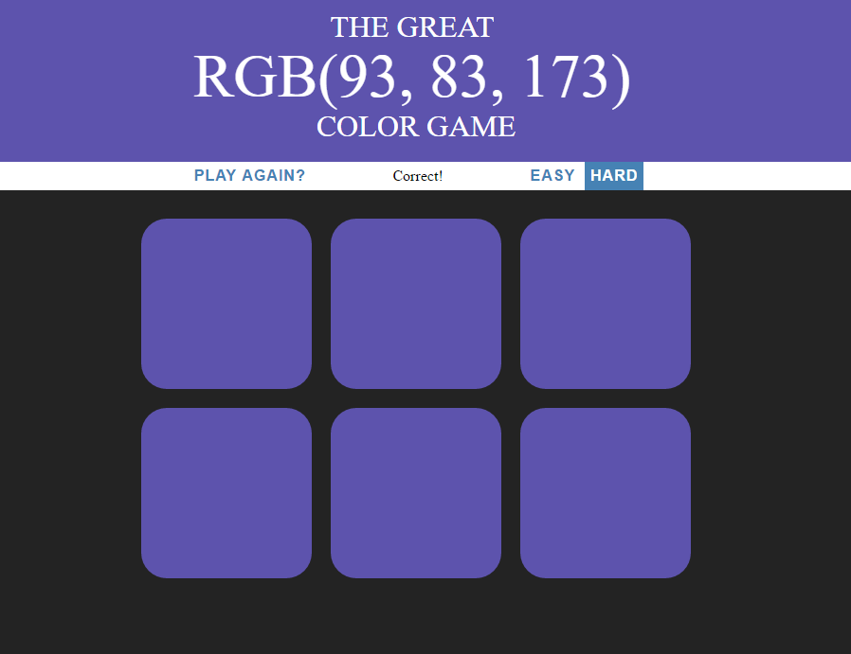

Figure 4: When the correct color is clicked all the blocks will reappear with that correct color as well as the header background will change to the same color. The message will now say “Correct!”. Notice the ‘New Colors’ button has changed with text saying “Play Again?” this will reset the colors again and change the header background back to the default.